CS 346 - Telecommunications and Networks

**LAB 11 - Switching, Network Topology, Loops, Spanning Trees, Kruskal’s Algorithm, Primm’s Algorithm, Spanning Tree Protocol**

In this lab we will examine a common problem that occurs when implementing scalable switched networks. As a network is scaled its topology becomes more complicated. It becomes more likely that a loop will be introduced into the network topology. An unhandled loop in a switched network will BREAK the network.

Spanning Trees are a common solution for handling loops in a network. A Spanning Tree is a graph that has no loops in it. Kruskal and Primm are algorithms that generate a minimum spanning tree from a given weighted graph.

**Prerequisites**

Read Chapter 8 of the Course Textbook.

**Setup**

You’ll need a browser to follow links, and a document editor to construct your deliverables.

**Network Topology**

As a network scales the topology of the network will often become more complicated. The following is an adequate introduction to the possible network topologies you may encounter:

<https://beginnersbook.com/2019/03/computer-network-topology-mesh-star-bus-ring-and-hybrid/>

**Loops**

As a switched network scales up loops will often be introduced. This can cause problems. The following article will explain switching loops and why they can cause problems:

<https://www.computernetworkingnotes.com/ccna-study-guide/layer-2-switching-loops-in-network-explained.html>

**Spanning Trees**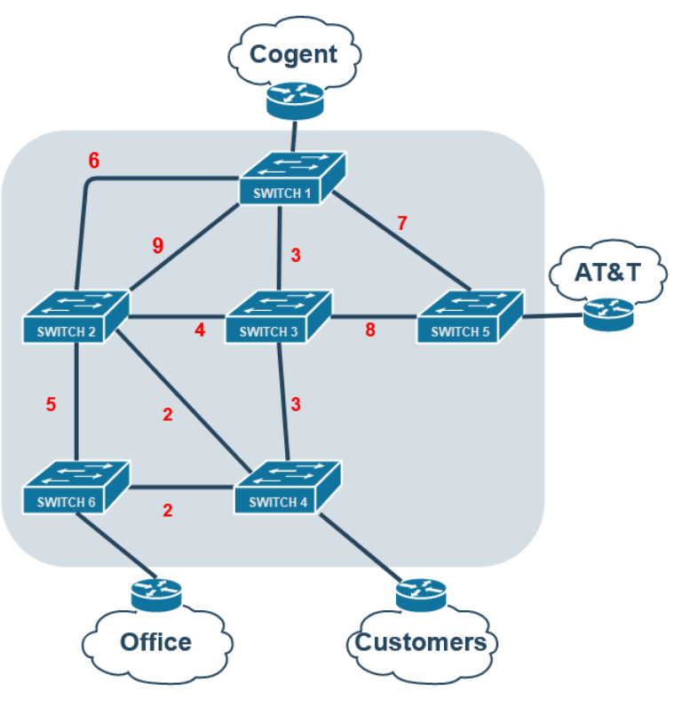

Spanning Trees are graphs that have no loops, calculating a spanning tree for a looped switched network will solve the above issue discussed:  
<https://www.tutorialspoint.com/data_structures_algorithms/spanning_tree.htm>

**Kruskal's Algorithm**  
An algorithm for generating minimum spanning trees from a given graph. First read about and learn Kruskal’s Algorithm:  
<https://www.tutorialspoint.com/data_structures_algorithms/kruskals_spanning_tree_algorithm.htm>

Now Use Kruskal’s Algorithm to find the minimum spanning tree for the above switched network:

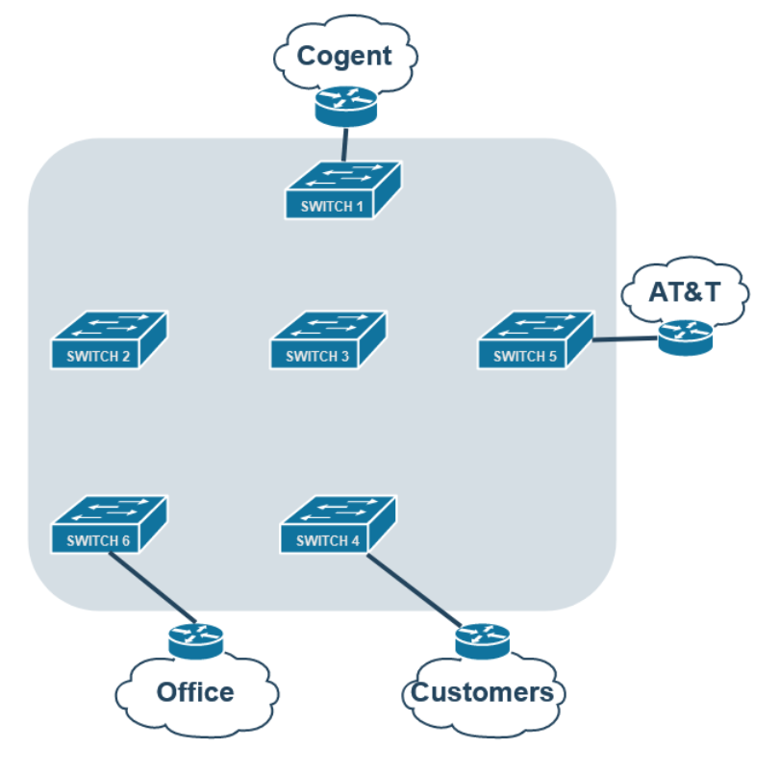

**Primm’s Algorithm**

First read about and learn Primm’s Algorithm:

<https://www.tutorialspoint.com/data_structures_algorithms/prims_spanning_tree_algorithm.htm>

Now Use Primm’s Algorithm to find the minimum spanning tree for the same network:



**The Spanning Tree Protocol**

Read the following book chapter all the way up to and including the “Spanning Tree Protocol”:  
<https://book.systemsapproach.org/internetworking/ethernet.html>

Then read the following tutorial about the spanning tree protocol

<https://www.computernetworkingnotes.com/ccna-study-guide/stp-spanning-tree-protocol-explained-with-examples.html>

Now use the steps from the spanning tree protocol to again complete the given diagram:



**Deliverables:**

3 Minimum Spanning Tree Network Diagrams

1. Kruskal
2. Primm
3. Spanning Tree Protocol

Answer The following:

1. What are the 5 common network topology types in computer networking?
2. Which topology requires the most cables to physically implement?
3. Which of these topologies provides easy fault detection?
4. Which of these topologies are considered “easy to install”?
5. What type of data is stored in a switch’s “CAM Table”?
6. What two types of addresses does a switch never store?
7. When a packet loops around a network endlessly it is called a _____?
8. What are the 3 major problems created by switching loops?
9. How many possible spanning trees can a disconnected graph with 7 nodes have?
10. How many nodes does a spanning tree with 7 edges have?
11. Which spanning tree algorithm treats the graph as a forest?
12. How did the spanning tree change with Kruskal vs Primm?

**Put the 3 minimum spanning tree network diagrams and the answers to the 12 questions into a .pdf document and submit to canvas under the LAB 11 Section.**

**An interesting read about the history of the spanning tree problem:**[**http://www.math.ucsd.edu/~ronspubs/85_07_minimum_spanning_tree.pdf**](http://www.math.ucsd.edu/~ronspubs/85_07_minimum_spanning_tree.pdf)